Contents

INTRODUTION 1

1.1 What is chatbot? And short history 1

1.2 What are significances of chatbot? 1

1.3 What are types of chatbot? 2

1.4 What is ChatGPT ? Discuss along with its history and differences with normal chatbots. 3

1.5 How chatGPT works? Explain with diagram. 3

References 4

# INTRODUTION

## 1.1 What is chatbot? And short history

A chatbot is a computer program designed to simulate a conversation with humans using natural language processing. Chatbots are often used in customer service, marketing, and other applications to deliver information and answer user questions. The history of chatbots dates back to the 1960s, when computer scientist Joseph Weizenbaum created a program called ELIZA that could imitate human conversation using simple pattern-matching techniques. ELIZA was designed to simulate a psychotherapist and was able to hold basic conversations with users, asking questions and providing answers based on user input. Other chatbots were developed in the following years, but it wasn't until the spread of the Internet and widespread use of messaging apps that chatbots became commonplace. Today, chatbots are used in many applications, including customer service, marketing and entertainment, and are constantly evolving with advances in natural language processing and machine learning.

## 1.2 What are significances of chatbot?

Chatbots offer a number of important benefits, including:

Availability: Unlike personal customer service agents, chatbots can be available to users 24/7, providing fast and efficient customer support or answering questions at any time of the day.

Scalability: Chatbots can handle multiple conversations simultaneously, allowing businesses to scale their customer service without hiring additional staff.

Usability: The usability of the chat had a positive effect on the extrinsic values ​​of the customer experience, while the responsiveness of the chat had a positive effect on the intrinsic values ​​of the customer experience. In addition, online customer experience had a positive relationship with customer satisfaction, and personality moderated the relationship between Chabot usability and external customer experience values.

Reliability: It is defined as the ability to perform the promised service reliably and provide users with accurately reliable performance and information.

Cost-effective: Chatbots are cost-effective compared to human agents because they require little maintenance and can handle a large number of queries simultaneously.

Increased engagement: Chatbots can increase user engagement by providing personalized responses and recommendations based on user input and history.

Improved efficiency: Chatbots can provide information and solutions quickly and accurately, reducing the time and effort users need to find what they need.

Data Collection: Chatbots can collect data about user interactions and provide valuable information about customer behavior and preferences.

Overall, chatbots provide businesses with a convenient and efficient way to provide customer support and interact with users, ultimately increasing customer satisfaction and loyalty.

## 1.3 What are types of chatbot?

There are several types of chatbots, including:

Rules-based chatbots: These chatbots use predefined rules to respond to user queries. They can give simple answers to common questions, but have a limited ability to understand natural language.

AI-powered chatbots: These chatbots use natural language processing (NLP) and machine learning algorithms to understand and respond to user queries. They can handle more complex queries and learn from user interactions over time.

Virtual Assistants: These chatbots are designed to help users with things like scheduling appointments, setting reminders, and making reservations. They can communicate with other applications and services to perform tasks on behalf of the user.

Social Media Chats: These chatbots are integrated into social media platforms such as Facebook, Twitter and Instagram and can respond to user questions and comments.

Voice assistants: These chatbots use speech recognition technology to interact with users through voice commands. For example, Siri, Google Assistant and Alexa.

Multilingual Chatbots: These chatbots can interact with users in multiple languages, making them useful for businesses with a global customer base. In general, the type of chat you use depends on the needs of the business and the complexity of user requests.

## 1.4 What is ChatGPT ? Discuss along with its history and differences with normal chatbots.

ChatGPT is a large language model based on the OpenAI GPT-3.5 architecture, trained on massive amounts of data to understand and generate human language. It aims to simulate human-like conversations and respond to user questions using natural language processing. The history of ChatGPT can be traced back to the development of the original GPT model at OpenAI in 2018. Since then, several iterations of the GPT model have been released, each with greater sophistication and efficiency. ChatGPT is based on the GPT 3.5 architecture, which is the latest version of the GPT model. Unlike conventional chatbots, ChatGPT can generate human-like responses, making it more engaging and capable of handling more complex conversations. It can also understand the context of the conversation and respond accordingly, making it more versatile than rules-based chatbots. Another important difference between ChatGPT and traditional chatbots is that ChatGPT does not rely on predetermined rules or programming to generate responses. Instead, it uses machine learning algorithms to generate responses based on understanding natural language and the context of the conversation. Overall, ChatGPT represents a significant advance in natural language processing and the development of AI-based chatbots. Its ability to provide human responses and understand context makes it a promising tool for companies looking to improve their customer service and interact with users in a more personal way.

## 1.5 How chatGPT works? Explain with diagram.

ChatGPT works by processing user input through multiple neural networks. The input is first transformed into individual words or sentences and then fed into the neural network as input vectors. The neural network then generates a probability distribution of possible next words or phrases based on the context of the conversation and the model's training data. The word or phrase most likely to be the next response is then selected and the process is repeated until the conversation is complete.

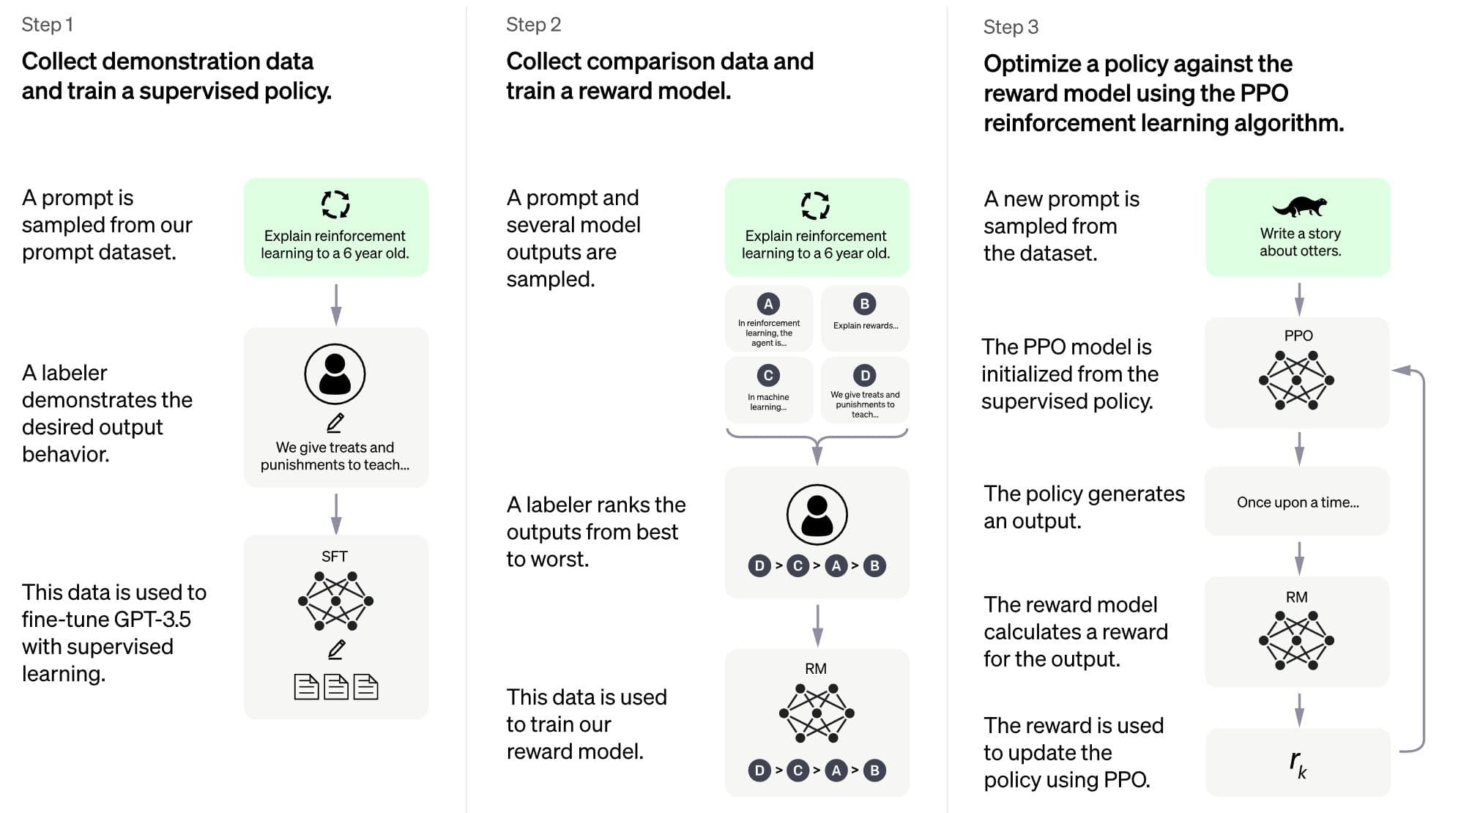

Figure: Workflow diagram of Chatgpt

In the diagram, user input is first transformed into individual words or sentences and then fed into the neural network as input vectors. The neural network generates a probability distribution of possible next words or phrases based on the context of the conversation and the model's training data. The chosen word or phrase is then used to generate the next response and the process is repeated until the conversation is complete.

# References

Ja-Shen Chen, T.-T.-Y. L. D. F., 2021. Usability and responsiveness of artificial intelligence chatbot on online customer experience in e-retailing. *International Journal of Retail & Distribution Management,* 7 May, 41(11), pp. 1512-1531.